|  |
| --- |
| **bluesky studios** |
| **Frosty Fight** |
| A froze shooter |
| Version #01  All work Copyright © 2016 by BlueSky Game Studios.  All rights reserved. |
| **Angela Liu** |
|  |



|  |
| --- |
| September 24th 2016 |

**Table of Contents**

Contents

Game Overview 4

Game Play Mechanics 4

Camera 4

Controls 4

Interface Sketch 4

Menu and Screen Descriptions 5

Characters 6

Enemies 6

Items 6

Scoring 6

Sound Index 6

Story Index 6

Art / Multimedia Index 7

**Version History**

Github link <https://github.com/COMP305-F2016/Assignment-1/commits/master>

V2.0

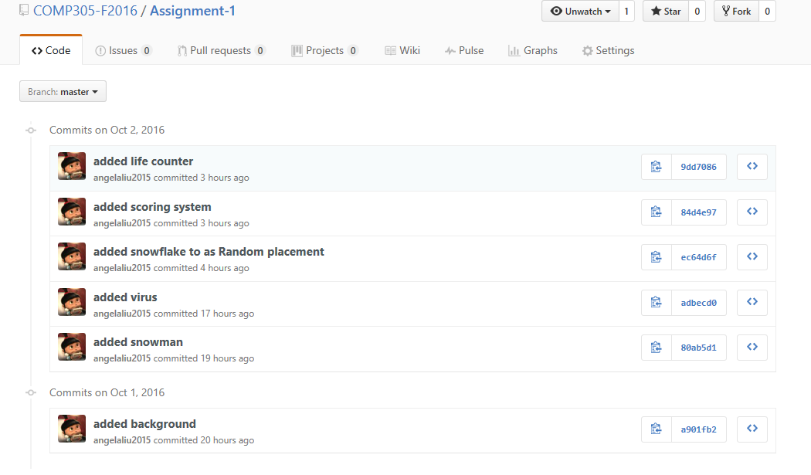

Version 1.0

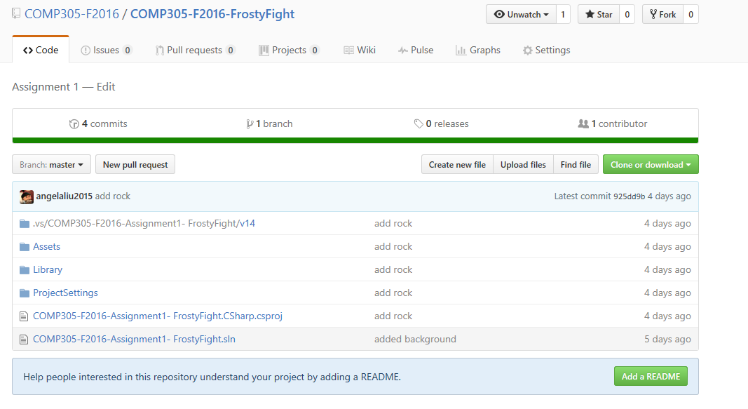

# Game Overview

*Frosty Fight is a simple retro top-down scrolling shooter game. The player’s avatar is a snowman (Olaf) who is limited to fly over a scrolling snowflake background and can only move side to side. The background scrolls in left to right direction. The player’s goal is to shot the viruses and meet Ana and Elsa snowflake on Ana’s birthday party.*

# Game Play Mechanics

*The player can use key or mouse as input.*

# Camera

*The camera for this game uses an orthographic project from a top-down (birds-eye) view.*

# Controls

*The game uses that mouse as the primary control mechanism.*

*The control for this game is with the mouse or key. The mouse allows the player to move left to right across the screen. It also can rotate the snowman.*

# Interface Sketch

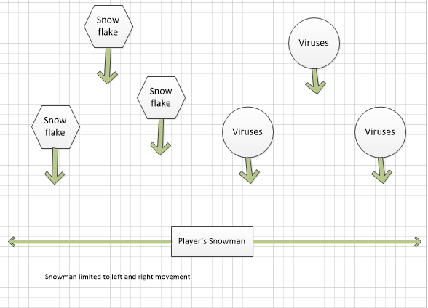

# Menu and Screen Descriptions

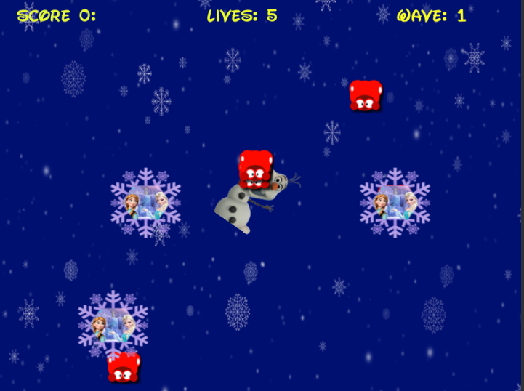

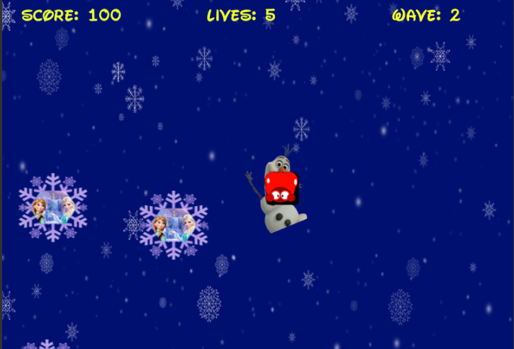

# Characters

*The player’s avatar is a simple snowman that seems to fly over a scrolling snowflake sky. The player movement can be rotated and fly from left to right or bottom to top. When snowman meets Ana and Elsa snowflake, the score will be increased.*

# Enemies

*The enemies in the game are the killer virus. Let’s image them as shooting lightning at the player.*

# Items

*The player meets the snowflake with Ana and Elsa picture. The scores will be increased.*

# Scoring

*Scoring in the game is accomplished by shooting the viruses. Each time the player’s snowman fly over snowflake with Ana and Elsa picture awards the player 10 scores. The player starts with 5 lives. Each time the player collides with a killer virus could he lose a lift.*

# Sound Index

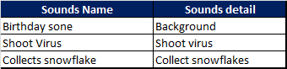

# Story Index

*This story is about some cold viruses encountered on Ana’s Birthday party. Snowman Olaf kills the viruses and also collects the snowflake with Ana and Elsa birthday picture.*

# Art / Multimedia Index

*(Include an index of all your graphic and video assets here)*

